**Guitar Looper Pedal Design**

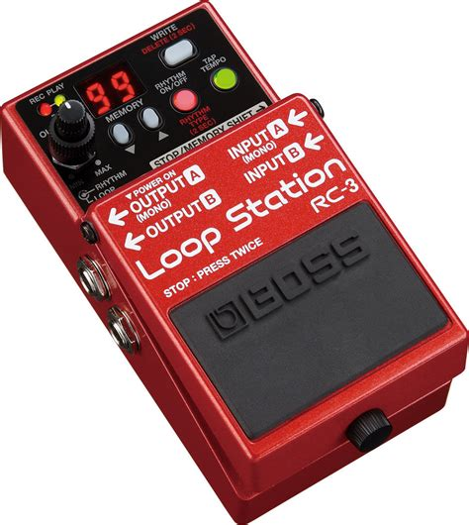

**Background**

Looper guitar pedals have been used for decades as a way for guitarists to create more depth and complexities to their music without sacrificing tone, volume, and speed. It can also be used in order to practice over chord progressions or rhythmic percussion.

**Purpose**

I am making this pedal in order to improve my tempo control, practice soloing over chord progressions, and develop my own custom sound, energy, and musicality. This project will also be used to supplement my curriculum in order to develop a greater understanding of circuitry and signals.

**Goals**

I am designing a fully functioning looping station with:

* an onboard metronome
* output volume control
* record and output a guitar loop
* learn and develop understanding of ADC, DAC, memory, and signal processing

Potential (nonessential) Additions:

* USB connectivity to upload loops
* Memory to store at least 4 saved loops

**Design**

**Looping Circuit**

This circuit will take in an audio signal input, store the input until the user ends the loop, then replay the signal. In other words, I will implement a record and play-back circuit. In order to provide a more in-depth learning experience for myself and loop with higher processing, I will not use a pre-fab record-playback board and simply replace the microphone with my guitar’s signal.

My initial thought was to create a signal path which began with an ADC (analog to digital) converter which would convert my signal into a digital signal allowing it to be saved to memory. Then, send the digital signal to an internal memory device, and send the saved signal to a DAC (digital to analog) converter. My initial thought is not to use a signal amplifier for the ADC and simply use an ADC that can read values from 300mV to 1.5V (approximately the signal strength output of electric guitar pickups). The DAC output should therefore range from 300mV to 1.5V as well.

(Future) In order to implement various saved loops, I will add an interface to select loops from memory (1-4). I think having 5 modes: 1 for live looping and 4 for saved loops would be the most user-friendly method and most straightforward to build. The alternative would be using 2 modes, 1 for live looping and 1 for saved loops with another 4 modes to select the loop. This would require 2 multiplexers when only one can be used. Therefore, the mode select requires 3 bits: the first bit will determine live/saved loops (0XX live, 1AB saved). The last two determine which saved loop will be chosen (00,01,11,10) and will be controlled by a sequential step function.

**Materials**

For the recorder and playback I am looking at a ISD174 which samples at 12 kHz for 26 seconds. 12 kHz will be enough to prevent aliasing of the highest frequency guitar signal which is ~5.8kHz. I will be using wire wound resistors because of their low noise for amplifications.

**Block Diagrams**

Figure ISD174 Block Diagram